
DEPARTMENT OF COMPUTER SCIENCE AND
ENGINEERING LAB MANUAL
CS23432 – Software Construction
(REGULATION 2023)
RAJALAKSHMI ENGINEERING COLLEGE
Thandalam, Chennai-602015

Name: HEMALATHA L
Register No: 231801055
Year / Branch / Section: 2nd / AI&DS / AC
Semester: IV
Academic Year: 2024 - 2025

INDEX
S.No. | Date | Title
1. | 21/1/25 | Azure Devops Environment Setup.
2. | 21/1/25 | Azure Devops Project Setup and User Story Management.
3. | 28/1/25 | Setting Up Epics, Features, And User Stories for Project Planning.
4. | 11/2/25 | Sprint Planning.
5. | 18/2/25 | Poker Estimation.
6. | 25/2/25 | Designing Class and Sequence Diagrams for Project Architecture.
7. | 04/3/25 | Designing Architectural and ER Diagrams for Project Structure.
8. | 25/3/25 | Testing – Test Plans and Test Cases.
9. | 15/4/25 | Load Testing and Pipelines.
10. | 22/4/25 | GitHub: Project Structure & Naming Conventions.

EXP NO: 1 | AZURE DEVOPS ENVIRONMENT SETUP

Aim:
To set up and access the Azure DevOps environment by creating an organization through the Azure
portal.
INSTALLATION
1.Open your web browser and go to the Azure website: https://azure.microsoft.com/en-us/get-
started/azure-portal.
Sign in using your Microsoft account credentials.
If you don't have a Microsoft account, you can create one here: https://signup.live.com/?lic=1
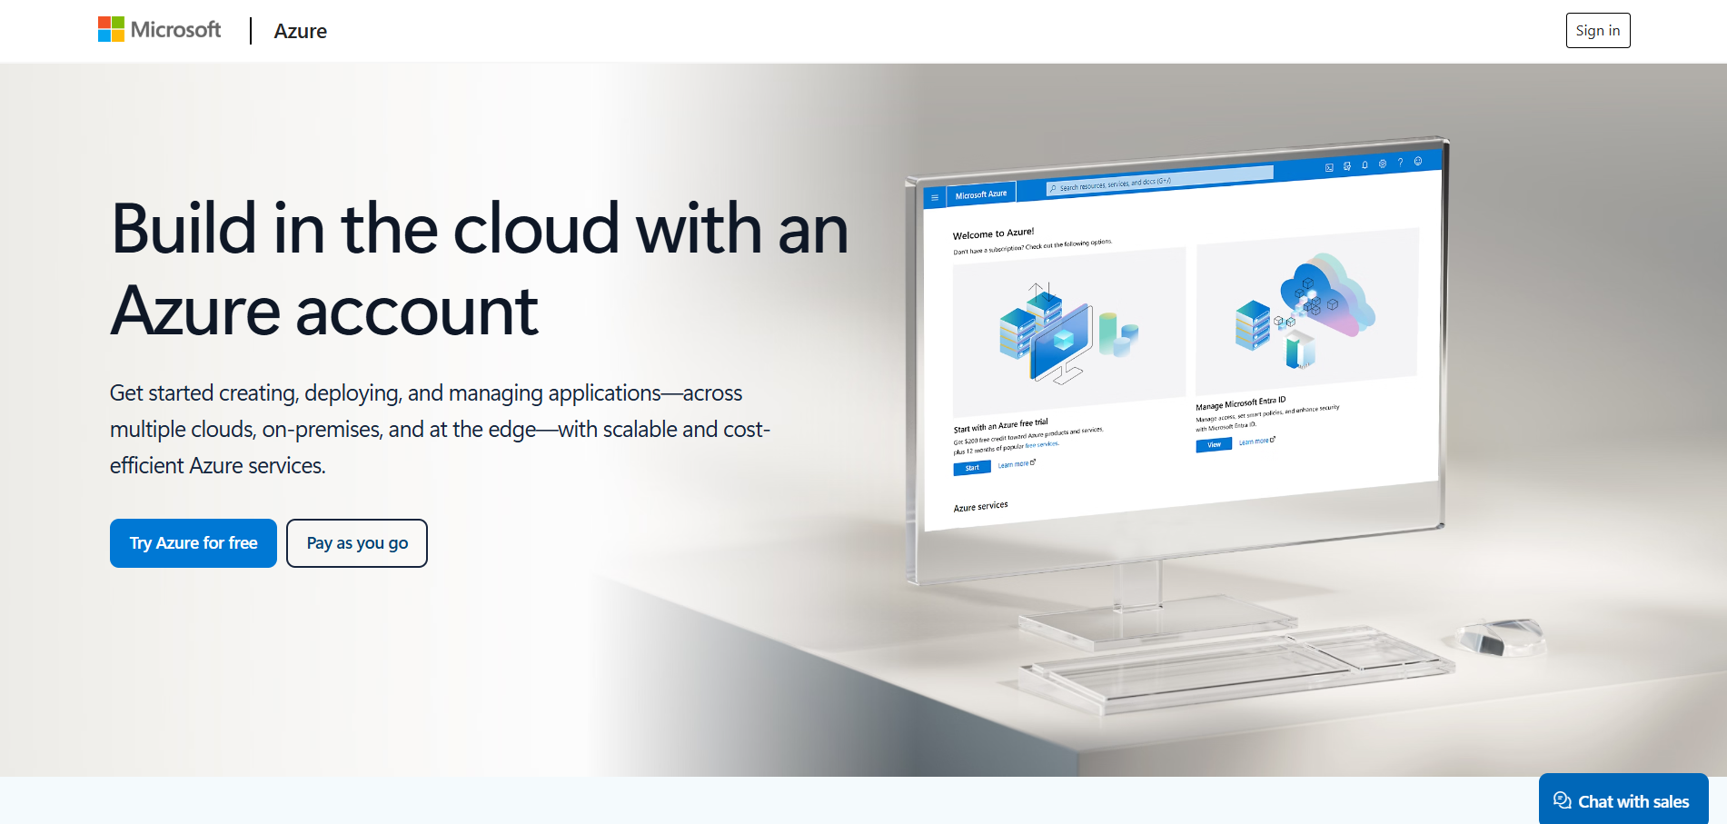

2.Azure home page
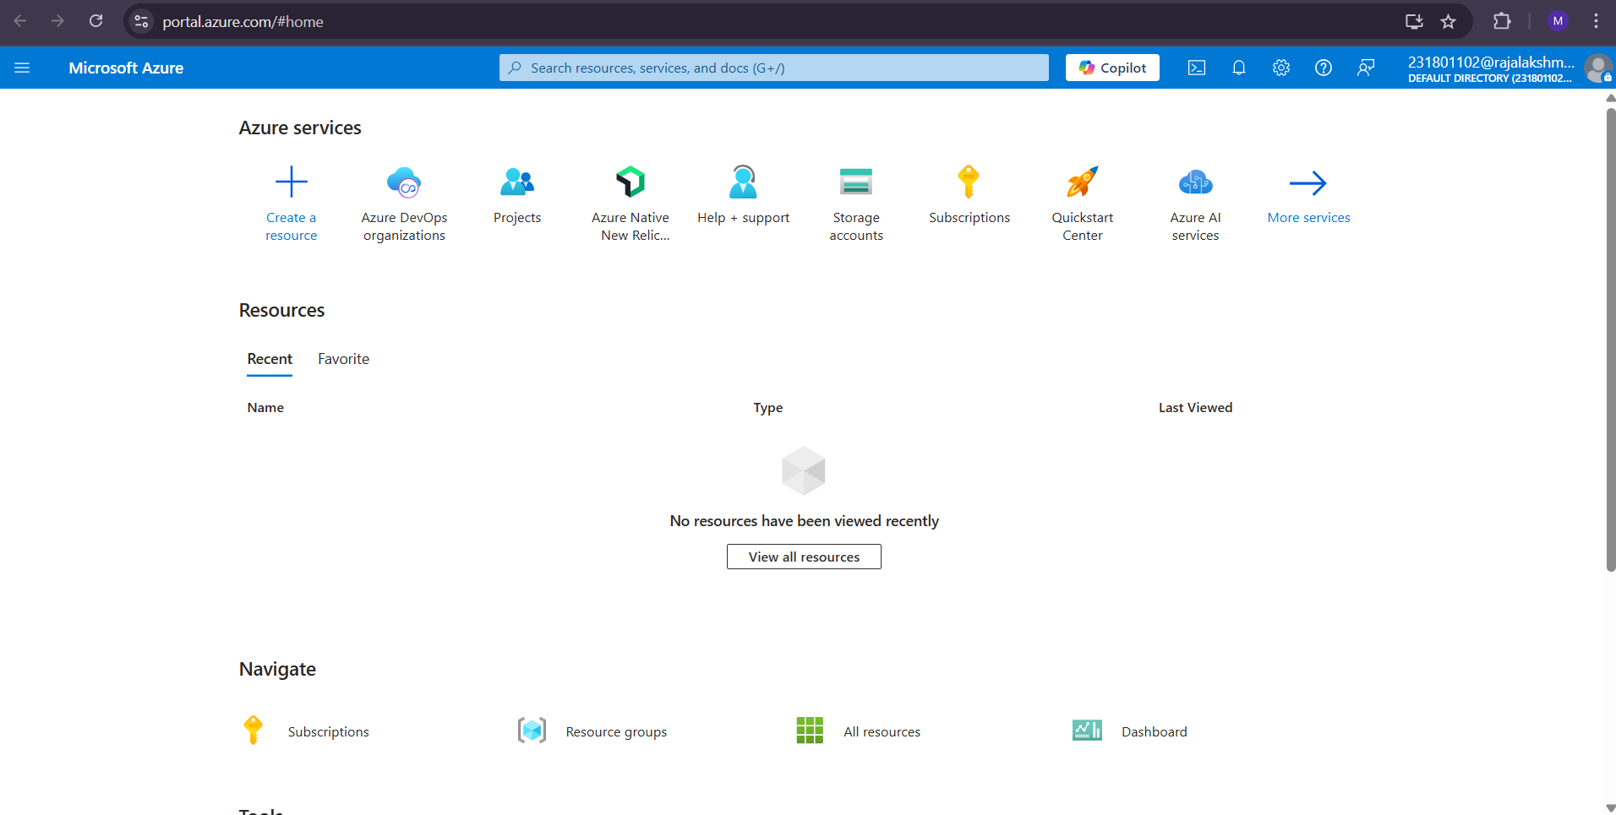

3. Azure DevOps Organizations
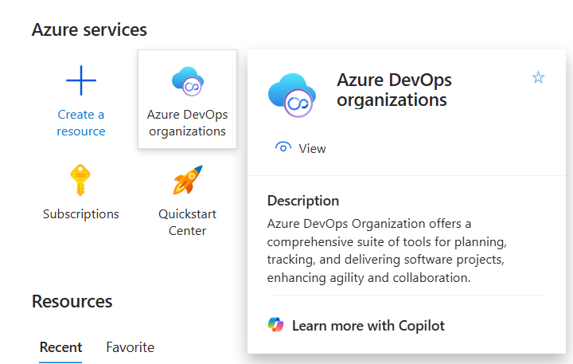
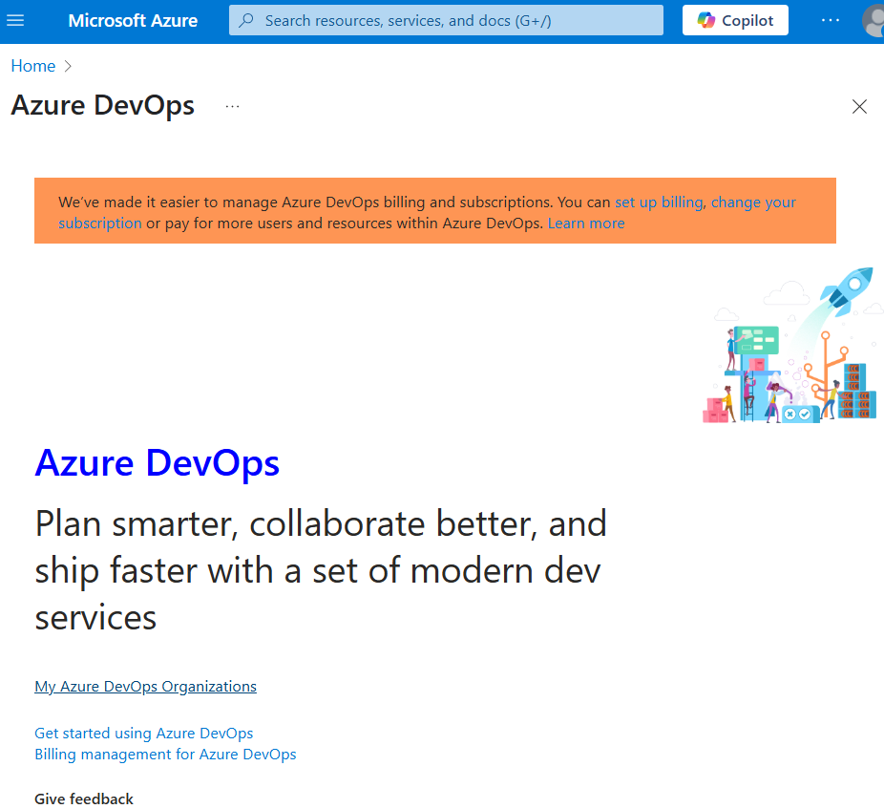

Result:
Successfully accessed the Azure DevOps environment and created a new organization through Azure portal.

EXP NO: 2 | AZURE DEVOPS PROJECT SETUP AND USER STORY  MANAGEMENT

Aim:
To set up an Azure DevOps project for efficient collaboration and agile work management.
1.Create An Azure Account
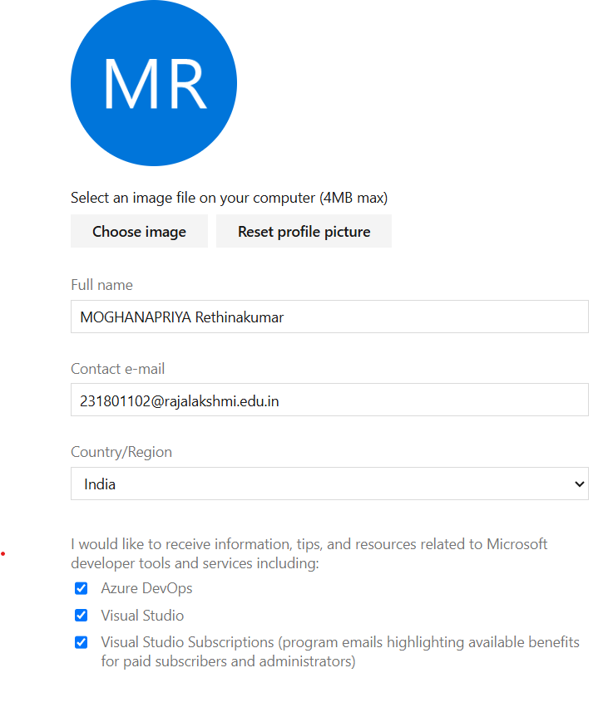

2.Create the First Project in Your Organization
a. After the organization is set up, you’ll need to create your first project. This is where you'll
begin to manage code, pipelines, work items, and more.
b. On the organization’s Home page, click on the New Project button.
c. Enter the project name, description, and visibility options:
Name: Choose a name for the project (e.g., LMS).
Description: Optionally, add a description to provide more context about the project.
Visibility: Choose whether you want the project to be Private (accessible only to those
invited) or Public (accessible to anyone).
d. Once you’ve filled out the details, click Create to set up your first project.
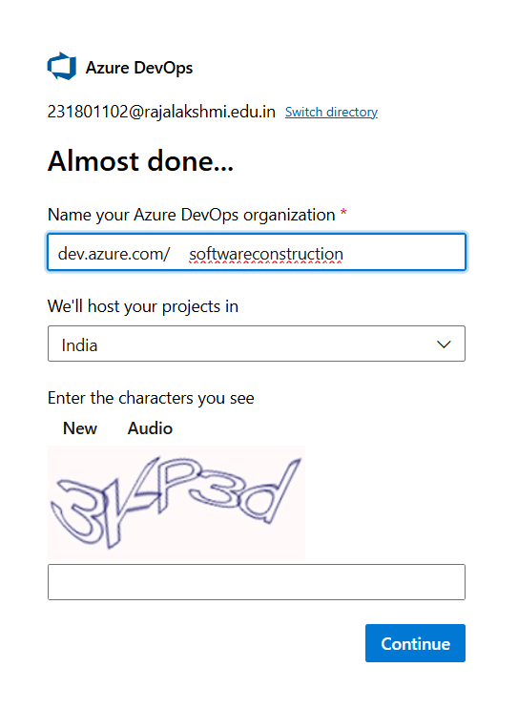
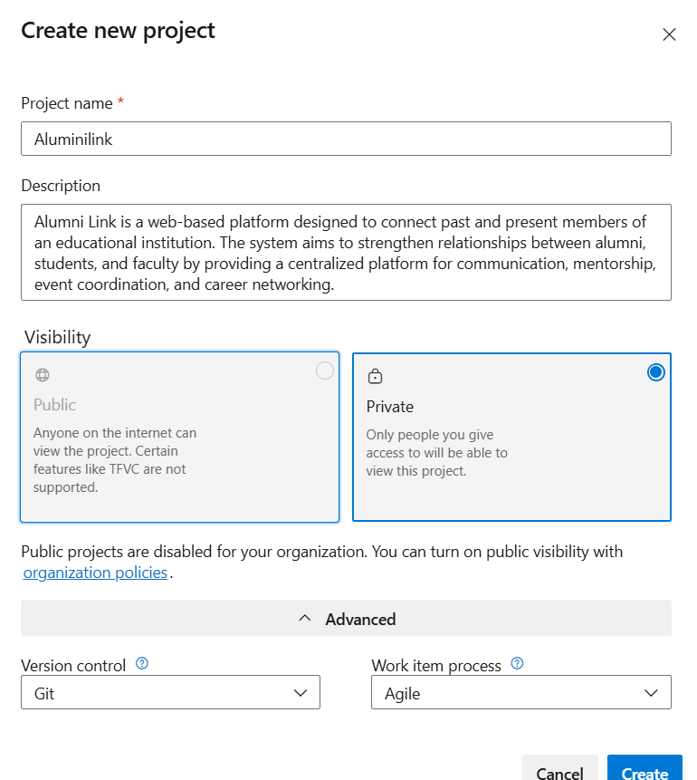

3.Once logged in, ensure you are in the correct organization. If you're part of multiple organizations, you
can switch between them from the top left corner (next to your user profile). Click on the Organization
name, and you should be taken to the Azure DevOps Organization Home page.
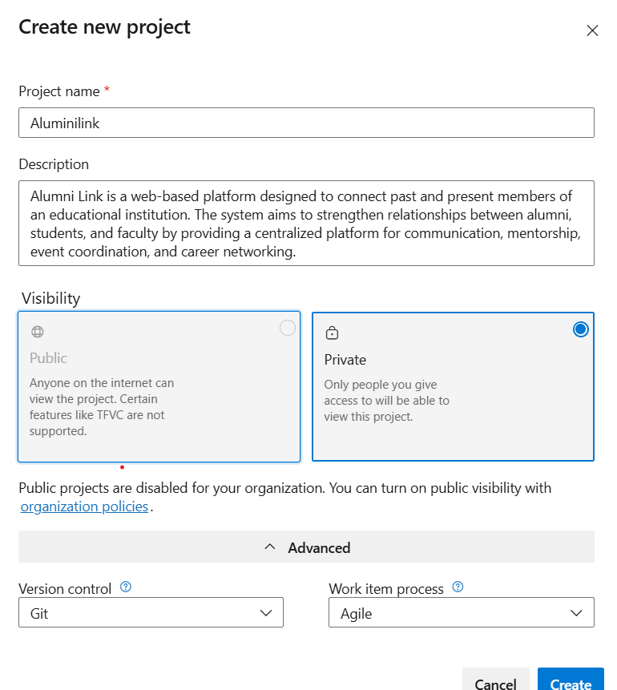

4.Project dashboard
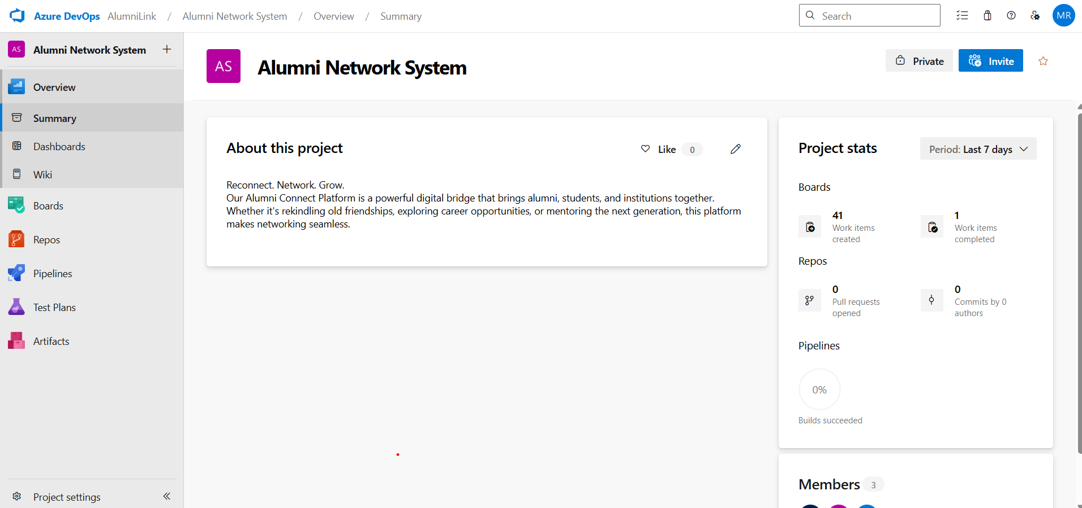
5.To manage user stories:
a. From the left-hand navigation menu, click on Boards. This will take you to the main Boards
page, where you can manage work items, backlogs, and sprints.
b. On the work items page, you'll see the option to Add a work item at the top. Alternatively,
you can find a + button or Add New Work Item depending on the view you're in. From the Add a work
item dropdown, select User Story. This will open a form to enter details for the new User Story.
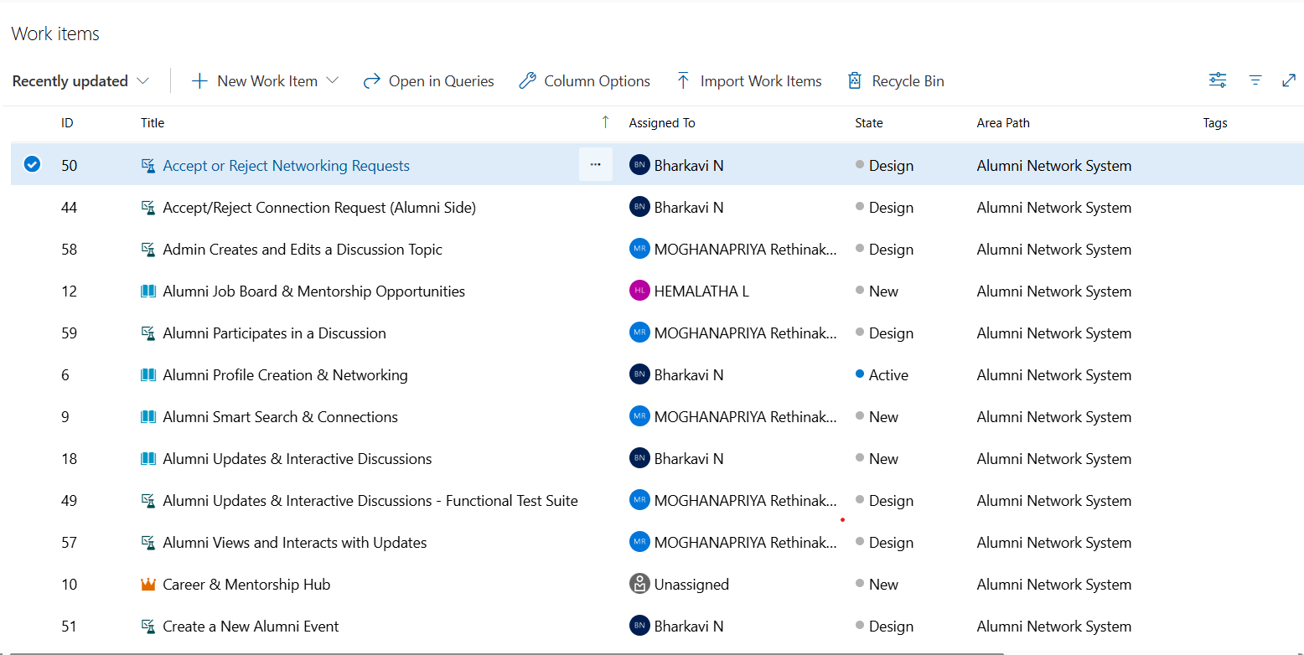

Result:
Successfully created an Azure DevOps project with user story management and agile
Workflow setup.

EXP NO: 3 | SETTING UP EPICS, FEATURES, AND USER STORIES  FOR PROJECT PLANNING

Aim:
To learn about how to create epics, user story, features, backlogs for your assigned project.

Create Epic, Features, User Stories, Task
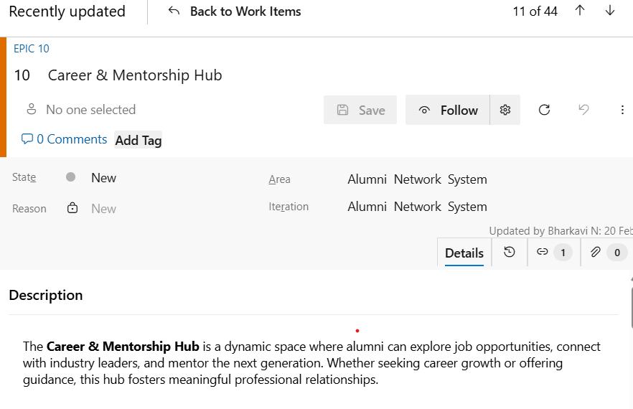
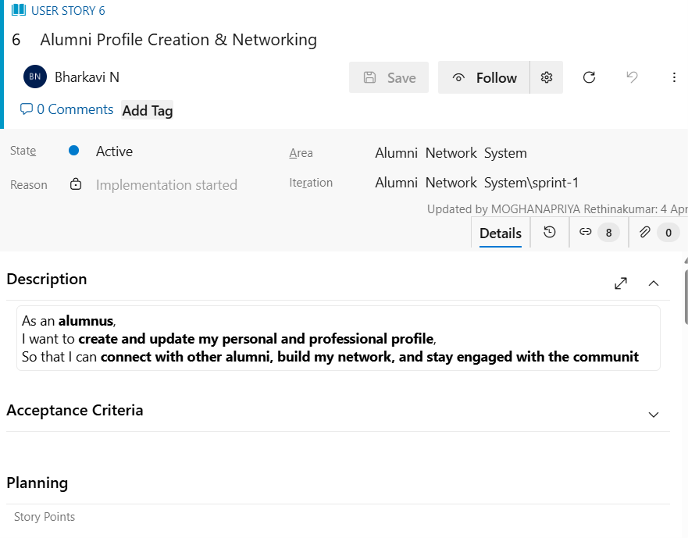
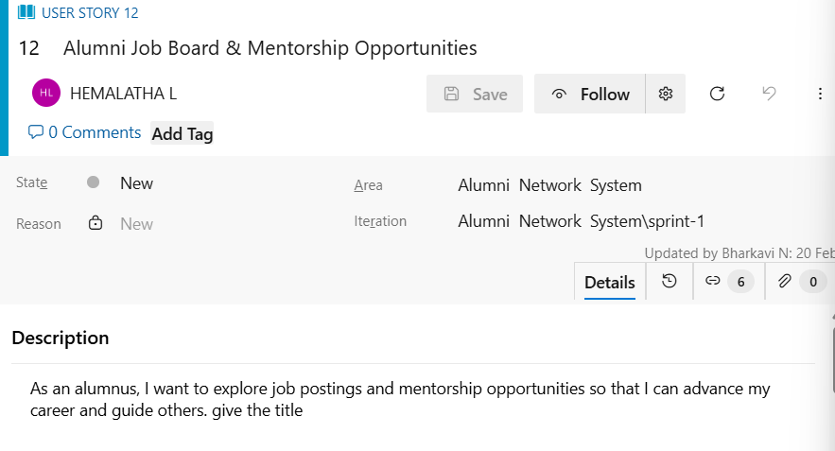
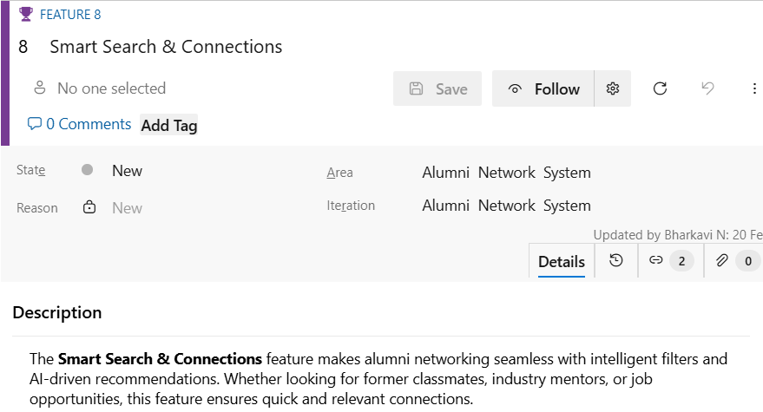

Result:
Thus, the creation of epics, features, user story and task has been created successfully.

EXP NO: 4 | SPRINT PLANNING

Aim:
To assign user story to specific sprint for the Music Playlist Batch Creator Project.
Sprint Planning
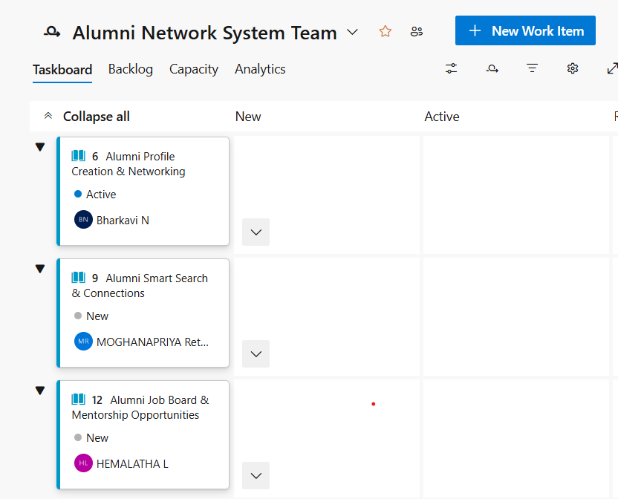

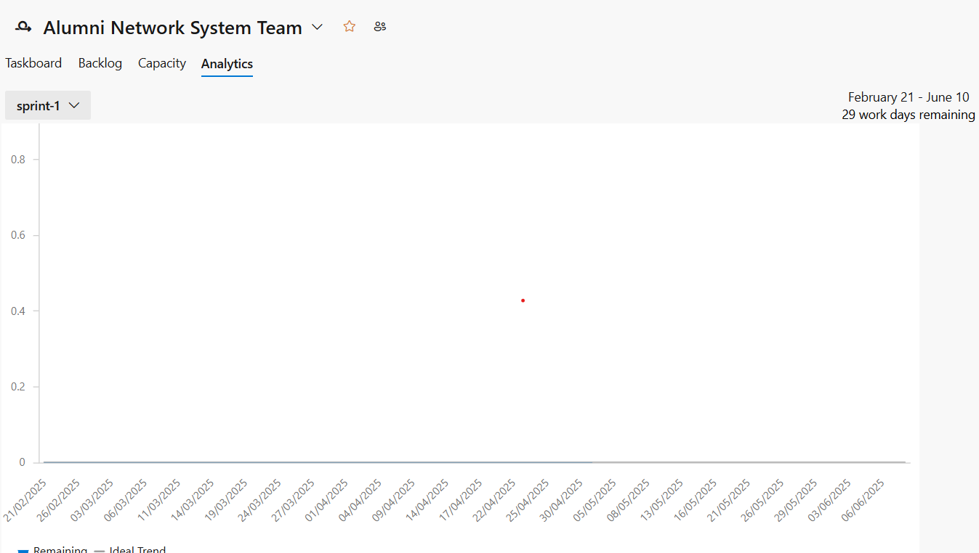

Result:
The Sprints are created for Alumni Network System Project.
EXP NO: 5 | POKER ESTIMATION

Aim:
Create Poker Estimation for the user stories - Alumni Network System Project.
Poker Estimation
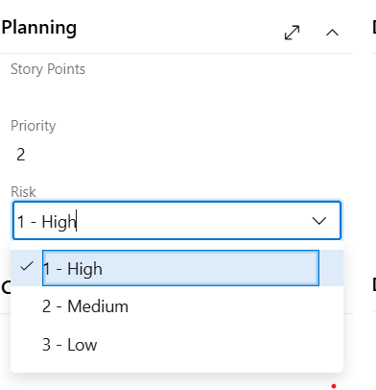

Result:
The Estimation/Story Points is created for the project using Poker Estimation.

EXP NO: 6 | DESIGNING CLASS AND STATE DIAGRAMS FOR  PROJECT ARCHITECTURE

Aim:
To Design a Class Diagram and Sequence Diagram for the given Project.
Class Diagram
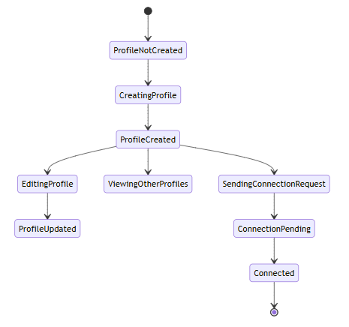
State diagram


Result:
The Class Diagram and state Diagram is designed Successfully for the Alumni Network System created.

EXP NO: 7 | dESIGNING ARCHITECTURAL AND ER DIAGRAMS  FOR PROJECT STRUCTURE

Aim:
To Design an Architectural Diagram and ER Diagram for the given Project.
Architectural Diagram
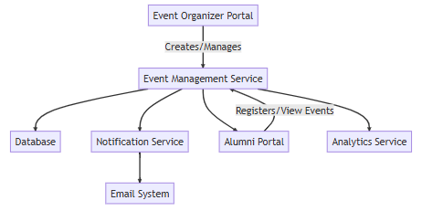
ER diagram
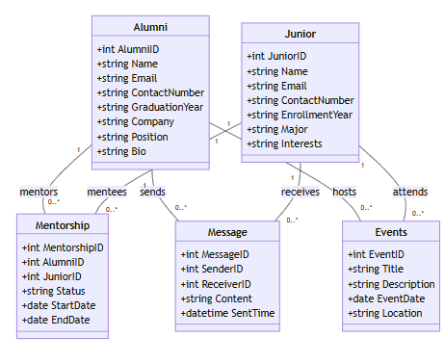

Result:
The Architecture Diagram and ER Diagram is designed Successfully Alumini Network System.

EXP NO: 8 | TESTING – TEST PLANS AND TEST CASES

Aim:
Test Plans and Test Case and write two test cases for at least five user stories showcasing the happy path and error scenarios in azure DevOps platform.
Test Suite TS01 – Alumni Profile Creation & Networking (ID: 201)
TC01 – Create Profile Successfully (Happy Path)
- Action:
  - Login with valid credentials.
  - Navigate to “My Profile” and fill out all required fields.
  - Click “Save Profile”.
- Expected Result:
Profile is saved and visible in the user's dashboard.
- Type: Happy Path
TC02 – Fail Profile Creation with Missing Fields (Error Path)
- Action:
  - Login and navigate to “My Profile”.
  - Leave required fields (e.g., name or batch) empty.
  - Click “Save Profile”.
- Expected Result:
Error: “All required fields must be filled.”
- Type: Error Path

Test Suite TS02 – Smart Search & Connections (ID: 202)
TC03 – Successful Alumni Search (Happy Path)
- Action:
  - Login and go to “Search Alumni”.
  - Enter filters (e.g., batch year = 2020).
  - Click “Search”.
- Expected Result:
List of matching alumni is shown.
- Type: Happy Path
TC04 – Search with No Results (Error Path)
- Action:
  - Enter non-existent criteria (e.g., batch = 1900).
  - Click “Search”.
- Expected Result:
Message: “No alumni found for the selected criteria.”
- Type: Error Path

Test Suite TS03 – Job Board & Mentorship (ID: 203)
TC05 – Apply for Job Successfully (Happy Path)
- Action:
  - Login and go to “Job Board”.
  - Select a job post and click “Apply”.
  - Submit application form.
- Expected Result:
Application submitted, confirmation shown.
- Type: Happy Path
TC06 – Application Fails for Closed Job (Error Path)
- Action:
  - Click “Apply” on an expired job listing.
- Expected Result:
Error: “This job listing has expired.”
- Type: Error Path

Test Suite TS04 – Updates & Discussions (ID: 204)
TC07 – Post an Update Successfully (Happy Path)
- Action:
  - Go to “Discussion Board”.
  - Type a message and click “Post”.
- Expected Result:
Message is posted and visible to others.
- Type: Happy Path
TC08 – Post Empty Message (Error Path)
- Action:
  - Try to submit without typing any message.
- Expected Result:
Error: “Message cannot be empty.”
- Type: Error Path

Test Suite TS05 – Secure Login & Signup (ID: 205)
TC09 – Successful Login (Happy Path)
- Action:
  - Enter valid email and password.
  - Click “Login”.
- Expected Result:
User is redirected to dashboard.
- Type: Happy Path
TC10 – Login with Wrong Password (Error Path)
- Action:
  - Enter correct email and wrong password.
  - Click “Login”.
- Expected Result:
Error: “Invalid credentials.”
- Type: Error Path
TEST CASE
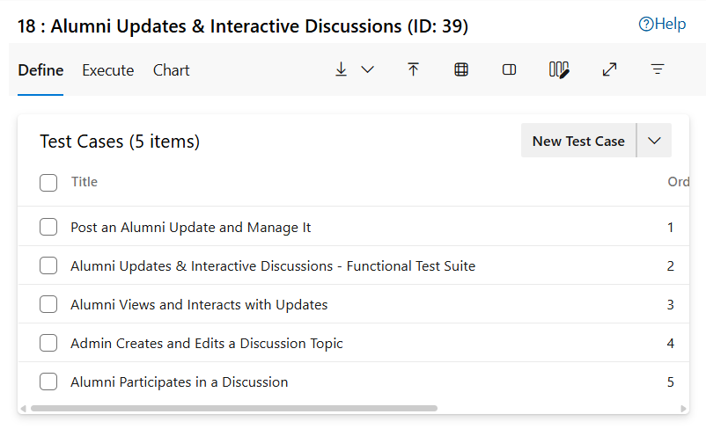

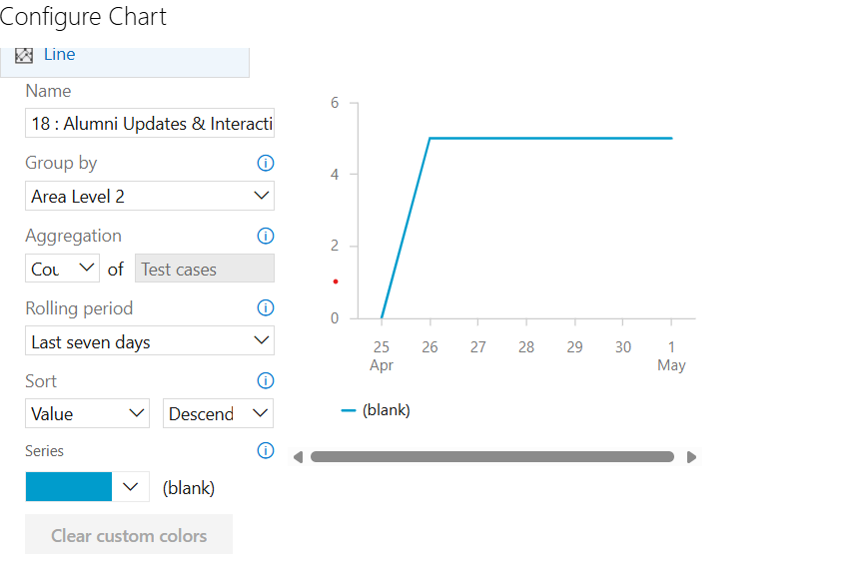

Result:
The test plans and test cases for the user stories is created in Azure DevOps with Happy Path and Error Path

EXP NO: 9 | LOAD TESTING AND PIPELINES

Aim:
To create an Azure Load Testing resource and run a load test to evaluate the performance of a target endpoint and to create and demonstrate an Azure DevOps pipeline for automating application builds,tests, and deployment.
Load Testing
Azure Load Testing:
Azure Load Testing allows you to simulate high traffic and stress tests for your web applications and APIs to understand how they perform under load. It helps identify performance bottlenecks, scalability ,issues, and optimize resource usage before deployment.
Steps to Create an Azure Load Testing Resource:
Before you run your first test, you need to create the Azure Load Testing resource:
1. Sign in to Azure Portal
Go to https://portal.azure.com and log in.
2. Create the Resource
o Go to Create a resource → Search for “Azure Load Testing”.
o Select Azure Load Testing and click Create.
3. Fill in the Configuration Details
Subscription: Choose your Azure subscription.
Resource Group: Create new or select an existing one.
Name: Provide a unique name (no special characters).
Location: Choose the region for hosting the resource.
4. (Optional) Configure tags for categorization and billing.
5. Click Review + Create, then Create.
6. Once deployment is complete, click Go to resource.

Steps to Create and Run a Load Test:
Once your resource is ready:
1. Go to your Azure Load Testing resource and click Add HTTP requests > Create.
2. Basics Tab
o Test Name: Provide a unique name.
o Description: (Optional) Add test purpose.
o Run After Creation: Keep checked.
3. Load Settings
o Test URL: Enter the target endpoint (e.g., https://yourapi.com/products).
4. Click Review + Create → Create to start the test.

Load Testing
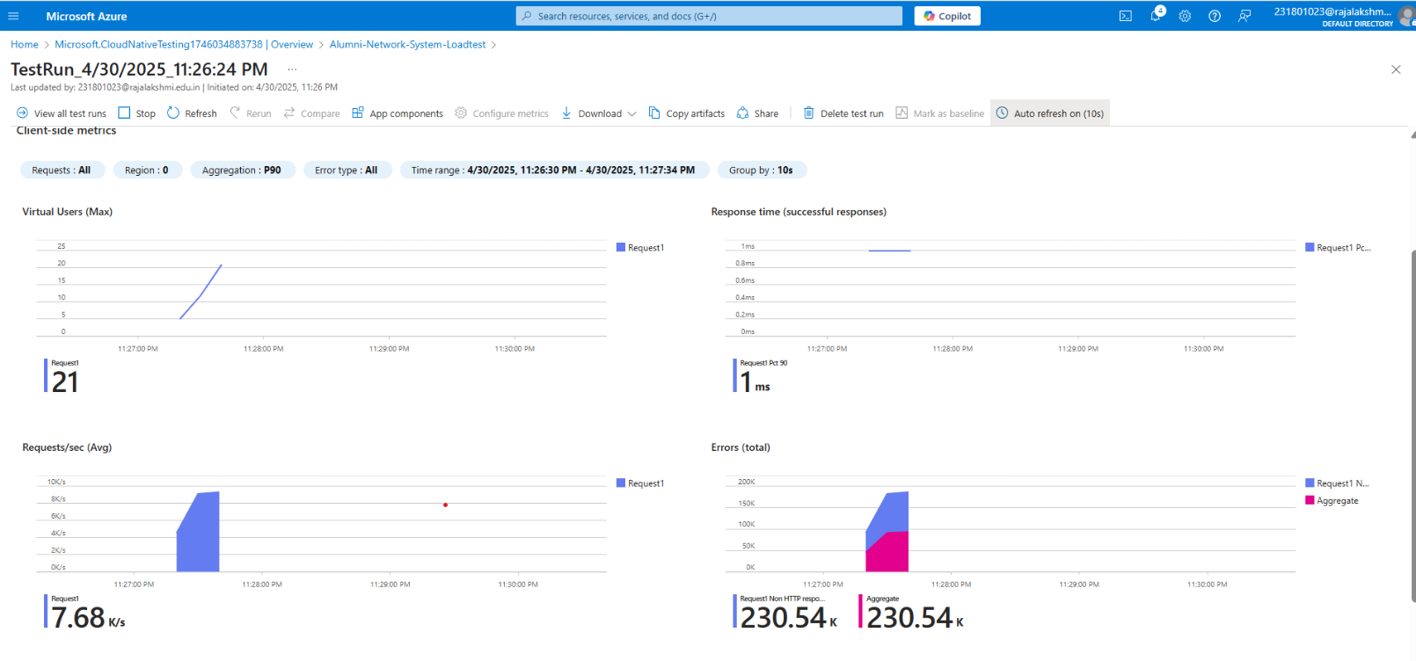
Pipelines
Description
The experiment demonstrates how to integrate a GitHub-hosted Flask-based Alumni Network System with Azure DevOps Pipelines. The pipeline automatically installs dependencies, performs environment checks, and ensures that every commit is verified for reliability. This approach enhances collaboration, CI/CD readiness, and deployment consistency
Connect GitHub to Azure DevOps
- Create a new project in Azure DevOps.
- Navigate to Pipelines > New Pipeline.
- Choose GitHub as the source and select your Alumni Network System repository.
- Authorize Azure DevOps to access your GitHub account.
- Proceed to configure the pipeline using yaml.

2. Create azure-pipelines.yml in Your Repo Root
- In your GitHub repo, add a new file at the root named azure-pipelines.yml.
3. What This Pipeline Does
- Checks out code from the GitHub repo.
- Sets up Python 3.x on an Ubuntu VM.
- Installs dependencies listed in your requirements.txt.
- Runs a simple Python script to confirm that the environment is working correctly.
4. Run and Monitor Your Pipeline
- Push/commit the azure-pipe lines. yml to the main branch.
- Go to Azure DevOps > Pipelines > Runs to monitor logs, errors, or success messages.
- You’ll see output confirming successful dependency installation and script execution.

YAML code
trigger:
- main

pool:
vmImage: ubuntu-latest

steps:
- checkout: self

- task: UsePythonVersion@0

inputs:
versionSpec: '3.x'
displayName: "Set up Python Environment"

- script: |
python -m pip install --upgrade pip
pip install -r alumni_project/requirements.txt
displayName: "Install Python Dependencies"

- script: |
python -c "print('Hello from Alumni Network System! Pipeline setup successful.')"
displayName: "Verify Python Setup"

Result:
Successfully created the Azure Load Testing resource and executed a load test to assess the performance of the specified endpoint and also demonstrated pipelines in azure devops.
EXP NO: 10 | GITHUB: PROJECT STRUCTURE & NAMING CONVENTIONS

Aim:
To provide a clear and organized view of the project's folder structure and file naming conventions,helping contributors and users easily understand, navigate, and extend the Alumini network system.
GitHub Project Structure
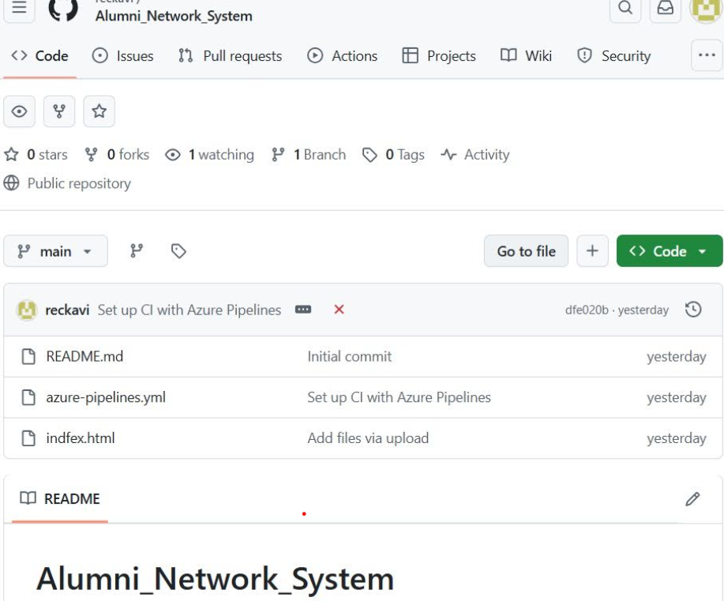

Result:
Successfully created the Azure Load Testing resource and executed a load test to assess the
performance of the specified endpoint and also demonstrated pipelines in azure devops.

